引入flash chart api文档说明

1. api 依赖spring框架存在
Spring配置文件 *.xml加入以下配置内容
<!-- 入口函数 -->
<bean id="flashChartService" class="com.report.flashchart.ifc.ChartServiceImpl" />

<!-- 饼图 -->
<bean id="pieChartService" class="com.report.flashchart.pie.impl.PieChartServiceImpl" />
<!-- 柱图 -->
<bean id="barChartService" class="com.report.flashchart.bar.impl.BarChartServiceImpl" />
<!-- 线图 -->
<bean id="lineChartService" class="com.report.flashchart.line.impl.LineChartServiceImpl" />

2.引用flash chart api需要的jar包
Flashchart内部使用的类
reportapi.jar

flex 需要的jar,如果工程已有不需要引入
backport-util-concurrent.jar
commons-collections-3.1.jar
ezmorph-1.0.4.jar
flex-messaging-common.jar
flex-messaging-core.jar
flex-messaging-opt.jar
flex-messaging-proxy.jar
flex-messaging-remoting.jar

扩展需要的包
json处理需要的包，如果工程已有不需要引入
json-lib-2.2.1-jdk15.jar
json.jar

spring需要的包，如果工程已有不需要引入
spring-aop.jar
spring-beans.jar
spring-context-support.jar
spring-context.jar
spring-core.jar
spring-jdbc.jar
spring-mock.jar
spring.jar
springmodules-validator-0.1.jar

3.需要加入工程项目的文件
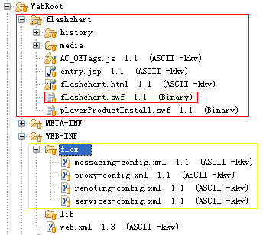
A.LucasReport\WebRoot\flashchart 添加或替换 **\WebRoot\flashchart
B.LucasReport\WebRoot\WEB-INF\flex添加或替换 **\WebRoot\WEB-INF\flex
C.web.xml文件配置
<!-- Flex 整合 -->
<display-name>BlazeDS</display-name>
<description>BlazeDS Application</description>

<!-- Http Flex Session attribute and binding listener support -->
<listener>
<listener-class>flex.messaging.HttpFlexSession</listener-class>
</listener>
<!-- MessageBroker Servlet -->
<servlet>
<servlet-name>MessageBrokerServlet</servlet-name>
<servlet-class>flex.messaging.MessageBrokerServlet</servlet-class>
<init-param>
<param-name>services.configuration.file</param-name>
<param-value>/WEB-INF/flex/services-config.xml</param-value>
</init-param>
<load-on-startup>1</load-on-startup>
</servlet>

<servlet-mapping>
<servlet-name>MessageBrokerServlet</servlet-name>
<url-pattern>/messagebroker/*</url-pattern>
</servlet-mapping>

<!-- flashChart内部action -->
<servlet>
<servlet-name>flashChartAction</servlet-name>
<servlet-class>com.report.flashchart.action.FlashChartAction</servlet-class>
</servlet>
<servlet-mapping>
<servlet-name>flashChartAction</servlet-name>
<url-pattern>/flashChartAction</url-pattern>
</servlet-mapping>

4.根据需求需要重写数据源实现类
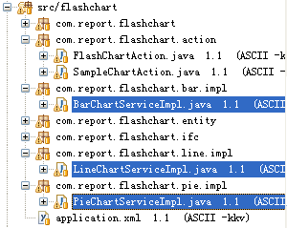
参照Sample类
com.report.flashchart.bar.impl.BarChartServiceImpl.java
com.report.flashchart.line.impl.LineChartServiceImpl.java
com.report.flashchart.pie.impl.PieChartServiceImpl.java
重写returnTestData及returnTestData2方法
修改前面第1步Spring配置文件 *.xml修改以下配置内容
将Sample类改成重写的实现类即可
<!-- 饼图 -->
<bean id="pieChartService" class="com.report.flashchart.pie.impl.PieChartServiceImpl" />
<!-- 柱图 -->
<bean id="barChartService" class="com.report.flashchart.bar.impl.BarChartServiceImpl" />
<!-- 线图 -->
<bean id="lineChartService" class="com.report.flashchart.line.impl.LineChartServiceImpl" />
5.自定义Action或Servlet指定输出地址
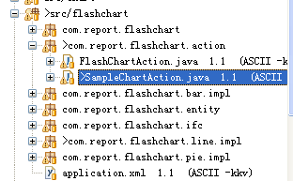
参照com.report.flashchart.action.SampleChartAction.java
